Lecture No. 16 PARASITOLOGY DR.Raad H.H.
Family Anoplocephalidae.
Genus Anoplocephala
Identification :
- 1 set of reproductive system in mature proglottid.
- 1 genital pore on one side .
- Eggs triangle with pyriform apparatus .
- Infects equine intestine .
- Intermediate host the oribatid mite
- Three species of tapeworms (Anoplocephala perfoliata, Anoplocephala magna).
Character | Anoplocephala perfoliata | Anoplocephala magna
Site | ileocecal junction. | Small intestine
Length | 8x1-2cm. | 8ox1-2cm.
scolex | Flaps as LAPPETS | Without LAPPETS

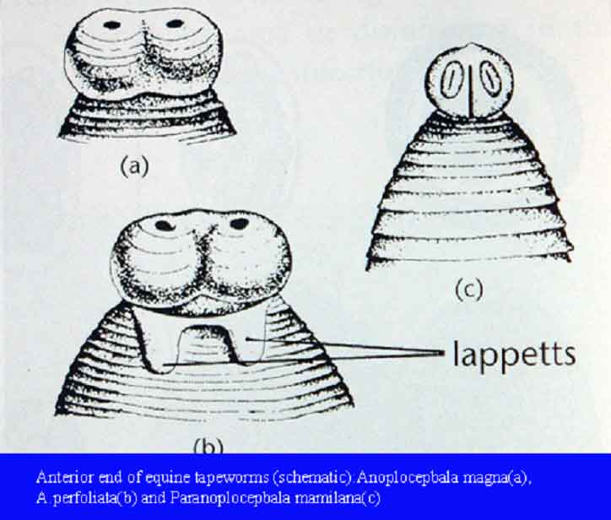

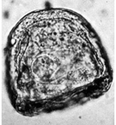

Note the "pyriform apparatus" around the oncosphere in the center of the egg.

- Clinical signs for which A. perfoliata should be considered as a possible cause are colic, poor growth, and unthriftiness. A. magna have been associated with enteritis.
- Treatment:
Copper sulfate / phenothiazine / Copper sulfate / nicotine sulfate / phenothiazine , Albendazole ,Fenbendazole ,Cambendazole, Oxfendazole /Bithionol /Niclosamid

Control:

Treat animals in the late spring or early summer. If necessary, treat again in the autumn. Infected mites on pasture can be controlled by plowing and reseeding pasture or by rotating pastures.

Genus Moniezia
Identification:
- 2 sets of reproductive system in mature proglottid , one on each side.
- Eggs more square , triangle with pyriform apparatus .
- Rosette-like Interproglottid glands between each segment with unknown function .
- Numerous testis ; ovary had horse shoe shape.
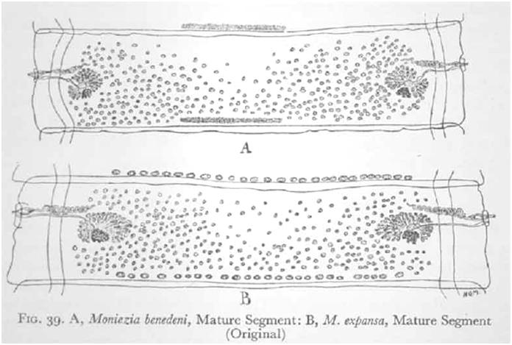

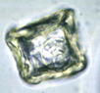
Egg; note square shape

- Species differentiation:
- M.expansa :1.5cm. x1-6 m. ; sheep ,goat ,cattle ,camel; Interproglottid glands as circular spots .
- M.benedeni : 2.5 cm.x1-4 m.; cattle ; Interproglottid glands as thin wide line.
- M. denticulate : 1.5cm. x 0.5m. ; ruminants ; without Interproglottid glands.
- M. trigonophore : like M.expansa.
- M.pallida : hrses ; ; Interproglottid glands as thin long line.
- Pathogenesis and Clinical Signs
Moniezia is quite prevalent in lambs, and calves under six months of age. Light infections with Moniezia spp. are of little importance. Workers in the US have not been able to detect any serious effects even from heavy burdens. One may observe that the intestine is a solid mass of tapeworms. They may cause diarrhea and unthriftiness. Obstruction of the intestine has been reported.
Genus Avitellina
Identification:
- 1 set of reproductive system in mature proglottid .
- Eggs oval pointed without pyriform apparatus .
- No vitelline gland.
- Genital pore changed without order between proglottids .
- 4 sets of testis
- Gravid proglottid contain Par-uterine organ.
- 2-4 m. length.
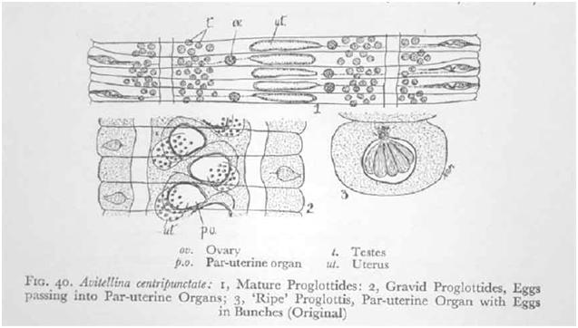

Genus Stilesia
Identification:
- 2 sets of testis
- Gravid proglottid contain pair of Par-uterine organ.
- Eggs oval without pyriform apparatus .
- Infects ruminants small intestine except S.hepatica in gall bladder.
- Length about 70cm.

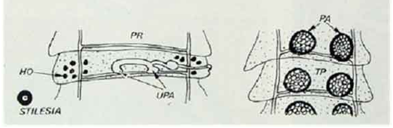

Family Thysanosomatidae
Genus Thysaniezia
- 1sets of testis
- Genital pore on one side changed without order between proglottids.
- Eggs oval without pyriform apparatus .
- Gravid proglottid contain pair of Par-uterine organ.
- Length more than 2m.
- Species Thysaniezia giardi :
occurs in the small intestine of sheep, goat and cattle. Appears to be of little pathogenic significance. Called also Helictometra giardi.
- Thysaniezia giardi, a milky-white organism that measures as much as 5 m in length and 10 mm in width; the organism consists of a head, neck, and numerous segments. The life cycle of the parasite has not been studied.
- Thysanieziasis occurs in the countries of the eastern hemisphere that have a moderate or warm climate, including the USSR, where it affects sheep more than one year old are particularly susceptible to infection. Sluggishness, salivation, and loss of coordination are the main symptoms of the disease. Epizootics usually occur among sheep in winter and fall.
- Thysaniezia giardi, heteroxenous, is accomplished with the participation of intermediate hosts, grass mites consist of the families: Scheloribatidae, Galumnidae, Liacaridae.
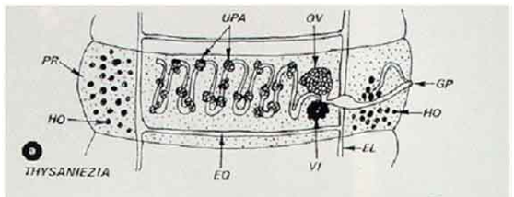

Family Davaineidae
Members of the family are characterized by the presence of a crown of rostellum at the tip of the scolex, and the rostellum is made up of mattock- or hammer-shaped hooks. The rostellum is surrounded by suckers which are armed with spines. Uterus in gravid segment contain egg capsule .These tapeworms are most commonly found in birds, and in few cases, mammals, which are the definitive hosts. Intermediate hosts are small insects such as ants.
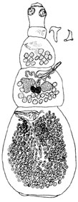
Genus Davainea
D. proglottina
- Most pathogenic spp. poultry tape worm.
- Inhabitants duodenum of birds.
- 3 x 0.5 mm.
- Scolex with rostellum and hooks , 4-9 segments .
- Gravid proglottid with egg capsule had 1 ova .
- Intermediate hosts Oribatid mites, slugs.
- causes severe enteritis in fowls and other birds.

Genus Raillietina
- Inhabitants small intestine of birds.
- Gravid proglottid with egg capsule had 1or more ova .
- Number of testes and a 2 ovaries are present in each mature proglottid.
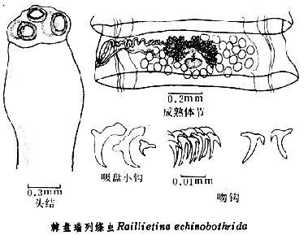
- Genital pore on one side.
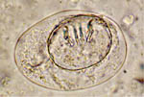
Egg.

Raillietina echinobothrida | R. tetragona | R. cesticillus
25 cm | 25 cm | 13cm.
Large scolex | small scolex | Large scolex
Rostellum with 200 hooks | Rostellum with 100 hooks | Rostellum with 400 -500 hooks
Egg capsule | Egg capsule with 6-12 ova | Egg capsule with 1 ova
Ants intermediate host | Musca and ant are intermediate host | Musca , beetles are intermediate host
Less pathogenic. | More Pathogenic | More Pathogenic

- The symptom is termed “nodular tapeworm disease” in poultry. Intestinal nodules often result in degeneration and necrosis of intestinal villi, accompanied by anaemia with a significant increase of total leukocyte counts and decrease of total serum protein.

Genus Cotugnia
- Number of testes and a 2 ovaries are present in each proglottid.
- 10cm.
- Large scolex
- Rostellum with tiny spines
- Gravid proglottid with egg capsule had 1 ova .
- Ants intermediate host
- C. digonopore most important spp.

Family Dilepididae
Uterus in gravid segment contain Transverse sac or egg capsule
Genus Amoebotaenia
- sphenoides :
- Inhabitants small intestine of birds.
- Body shape elongated triangle form ,24 segments ,about 4 mm.
- Genital pore on one side.
- Number of testes 12 are present in each mature proglottid.
- Uterus in gravid segment contain Transverse sac filled by eggs.
- Earthworm intermediate host.
- Less pathogenic.

Genus Choanotaenia
C. infundibulum
- Inhabitants small intestine of birds.
- Rostellum tith 20 hooks
- Uterus in gravid segment contain Transverse sac filled by eggs.
- Genital pore exchanged without order on one side.
- Egg with two hairs on lateral sides.
- Ants and beetles intermediate host.
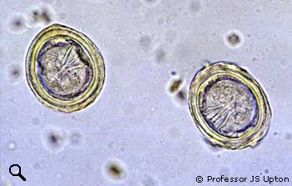
- Less pathogenic.
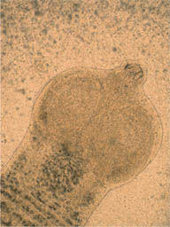

Genus Dipylidium
D.caninum
- ( dog tape worm )
- It is a common parasite of dogs & cats all over the world ; it is occasionally infect Human especially children ( human have solitary worm infection).
- Intermediate host lice & fleas of pets (dogs & cats).
- Its length average 15 cm. ( may be 80 cm.).
- Scolex : bears 4 suckers & have a conical retractile Rostellum armed with 3-5 circles rows of small hooks.
- mature proglottids have 2 sets Of genital organs & 2 genital pores , one on each Side .
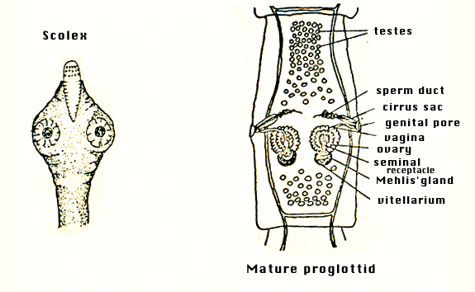
- gravid proglottids shape similar to Cucumber seed, size & color (or small, white, rice like bodies).

- They have poly – gonal “Egg capsule “ (each with 5 – 30 eggs ). The segments passed through feces could be motile .
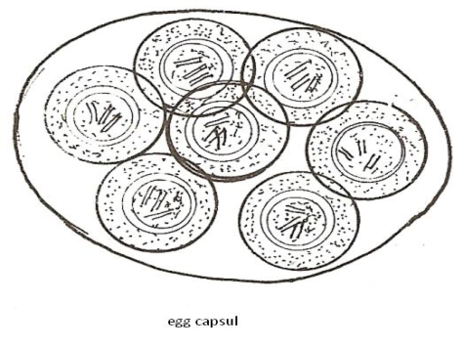

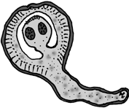

- Larval stage is Crypto cysticercoid.

- Pets , cat "Ctenocephalides" fleas & dog" Trichodectes" lice play great role in spread infection .
- Zoonotic infection.
- Fecal-oral transmission, more specifically ingestion of vector.
- Children age group mostly infected and show GIT disorders.

